**LAB # 05**

**Artificial Intelligence**



**Name : Alishba Waqar**

**Sap Id : 46997**

**Submitted to : Mam Ayesha**

**Task 01:**

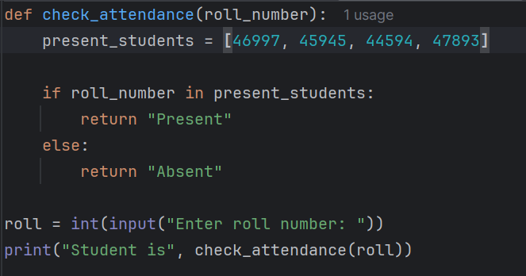

**Output:**

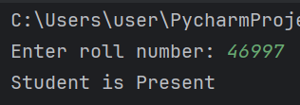

**Task 02:**

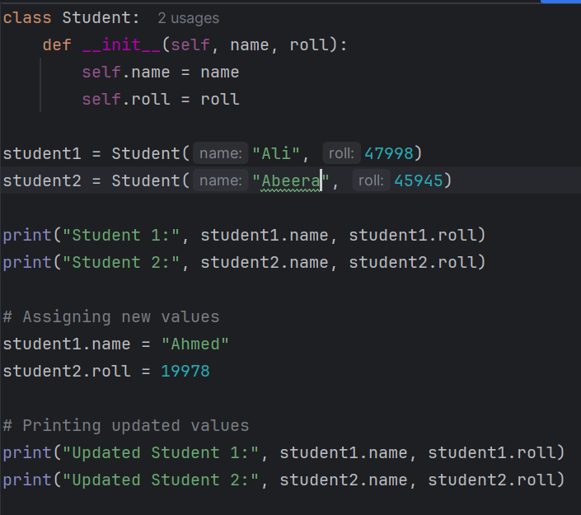

**Output:**

**Task 03:**

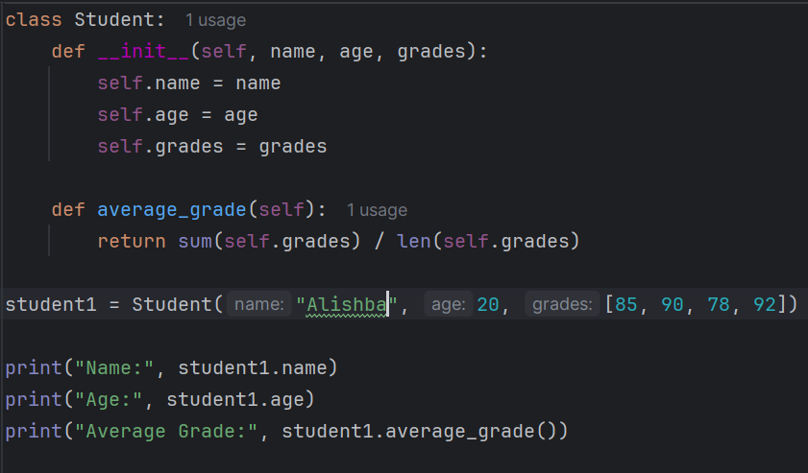

**Output:**

**Task 04:**

**Output:**

**Task 05:**

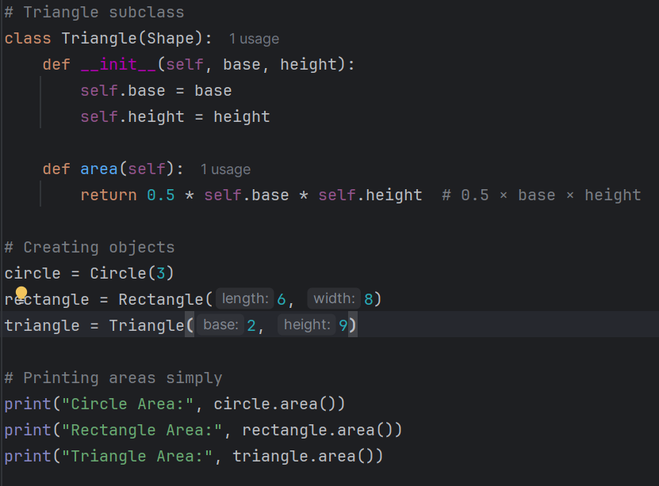

**Output:**

